 VINOD SIR’S GROUP TUTION

MARKS: 25 MATHS-I TIME: 1 Hr. 30 Mins.

Q. 1: Is the equation a linear equation in 2 variables ? [2]
1. 3x² - 7y = 13 2. 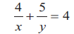

Q. 2: Solve the following simultaneous equations [4]
1. 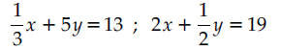
2.

Q. 3: Solve the following simultaneous equations graphically. [6]

1.
2.

Q. 4: Find the values of following determinants. [4]
1. 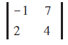 2. 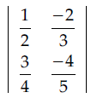

Q. 5: Solve the following simultaneous equations using Cramer’s rule. [6]

1.
2.

Q. 6: Solve the following simultaneous equations graphically. [3]

